**FINAL PROJECT: 3**

**ANALYSING THE IMPACT OF CAR FEATURES ON PRICE AND PROFITABILITY**

**Description:**

To help a car manufacturer optimize pricing and product development, we need to analyse how different car features, market segments, and prices impact consumer demand and profitability. By studying this data, we can identify which features which are most popular and profitable. Using techniques like regression analysis and market segmentation, we will uncover key insights that can guide pricing strategies to balance consumer preferences with profit goals. This analysis will also highlight which product features should be prioritized in future car models, helping the manufacturer stay competitive and boost long-term profitability.

The data provided for this project has been downloaded from the website of Trainity.

Data Cleaning- To obtain the desired output and to maintain the quality of data, cleaning is an important step.

All the blank data are removed, by using data tab all the duplicate data has been removed.

Formatting has been performed on some of the columns to align numerical data and to assign currency to the MSRP.

The data analysis process will help the car companies to enhance their sale and make good profit.

**Approach:**

* Pivot tables have been used to derive insights.
* Various visualization tools such as scatter plot, Bar charts, stacked column charts, Bubble charts have been used.
* For Regression analysis, Data analysis ribbon in Data Tab has been used.

**Tech-Stack Used:**

* I have used MS Excel, 2013 to do this project.
* Reason for choosing MS Excel is that it provides tools to perform different types of analysis such as statistical, regression, Pivot table, correlations etc. and also provides visualization tools to convey the insights to the customers.

**DATA ANALYSIS TASKS:**

* **Task 1.A:** Create a pivot table that shows the number of car models in each market category and their corresponding popularity scores.
* **Task 1.B:** Create a combo chart that visualizes the relationship between market category and popularity.

I have created a pivot table by keeping Market Category in Rows and average of popularity and count of models in value fields.

By using the Pivot table, I inserted the following graph to show the relationship between market category and popularity.

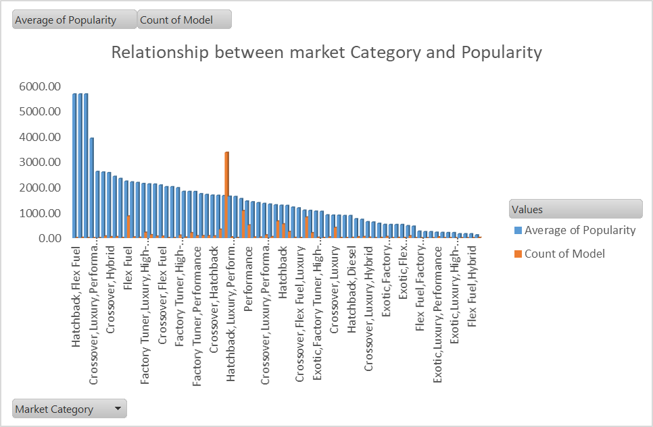

**Insights:**

Top 5 market categories based on average values are:



* **Task 2:** Create a scatter chart that plots engine power on the x-axis and price on the y-axis. Add a trend-line to the chart to visualize the relationship between these variables.

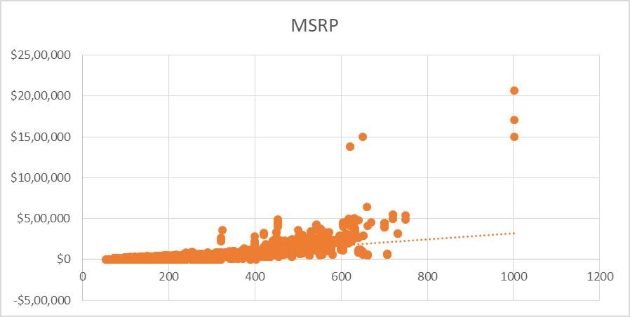

**Insights:**

It can be inferred from the scatter plot that there is a positive correlation between “price” and “Engine power” of the cars.

* **Task 3:** Use regression analysis to identify the variables that have the strongest relationship with a car's price. Then create a bar chart that shows the coefficient values for each variable to visualize their relative importance.

For this I had to change the non-numerical data into numerical data. I assigned values to each category to perform regression analysis.



* **Task 4.A:** Create a pivot table that shows the average price of cars for each manufacturer.
* **Task 4.B:** Create a bar chart or a horizontal stacked bar chart that visualizes the relationship between manufacturer and average price.

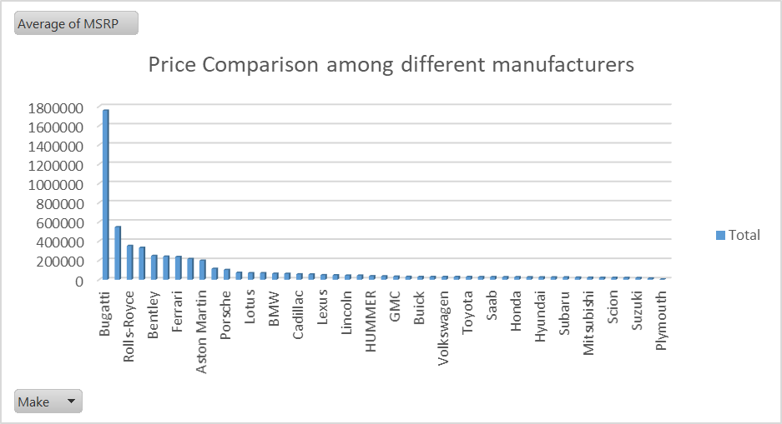

**Isight:**

It can be inferred from the chart that BUGGATI has the highest price among other car models followed by MAYBACH.



* **Task 5.A:** Create a scatter plot with the number of cylinders on the x-axis and highway MPG on the y-axis. Then create a trend-line on the scatter plot to visually estimate the slope of the relationship and assess its significance.

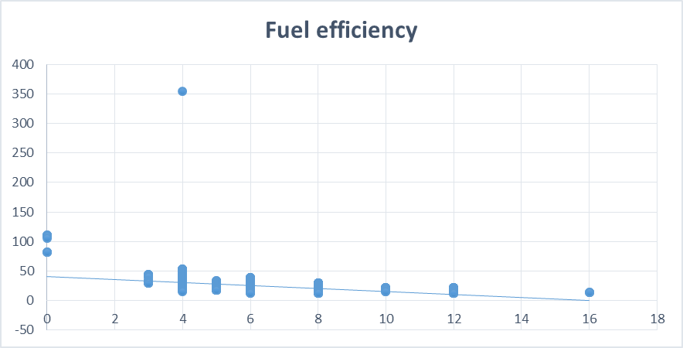

* **Task 5.B:** Calculate the correlation coefficient between the number of cylinders and highway MPG to quantify the strength and direction of the relationship.

=CORREL(D18:D26,E18:E26)



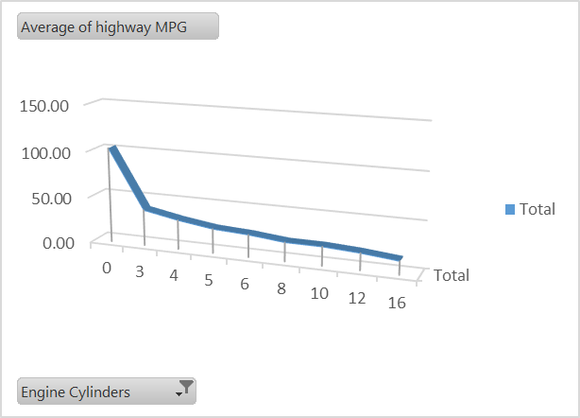

**Relationship between Engine cylinders and average of highway MPG**

**Insights:**

1. Highway MPG decreases with increase in the number of cylinders.



1. With the correlation factor of -0.7, it is clear that there is a negative correlation between number of cylinders and average MPG.

**DASHBOARD TASKS:**

Task 1: How does the distribution of car prices vary by brand and body style?

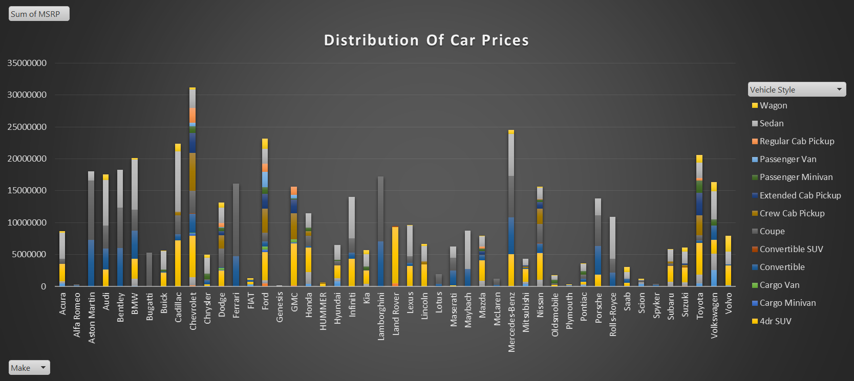

**Task 2:** Which car brands have the highest and lowest average MSRPs, and how does this vary by body style?

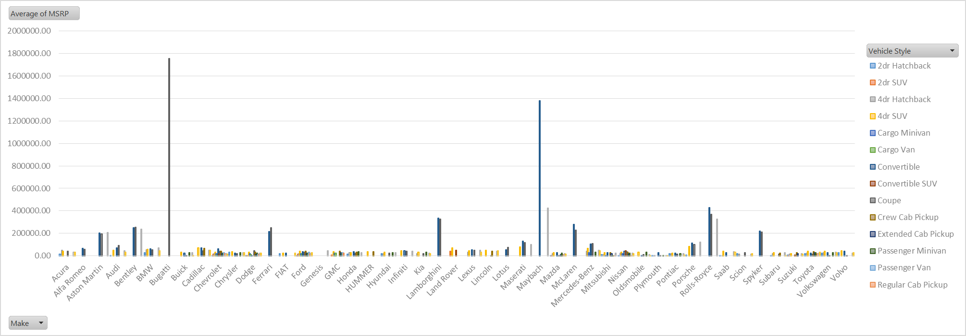

**Task 3:** How do the different feature such as transmission type affect the MSRP, and how does this vary by body style?

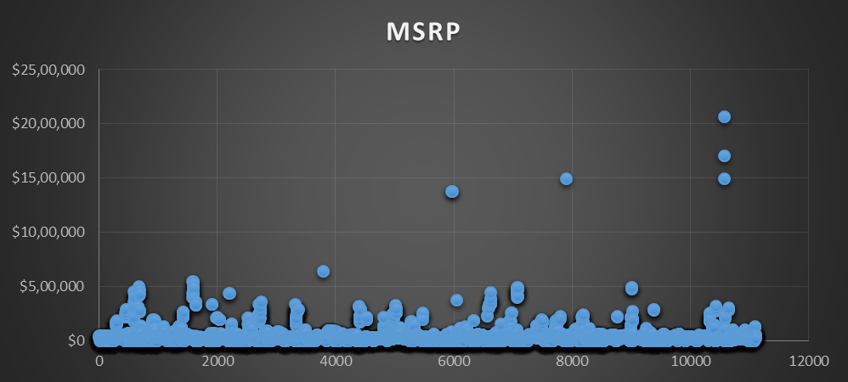

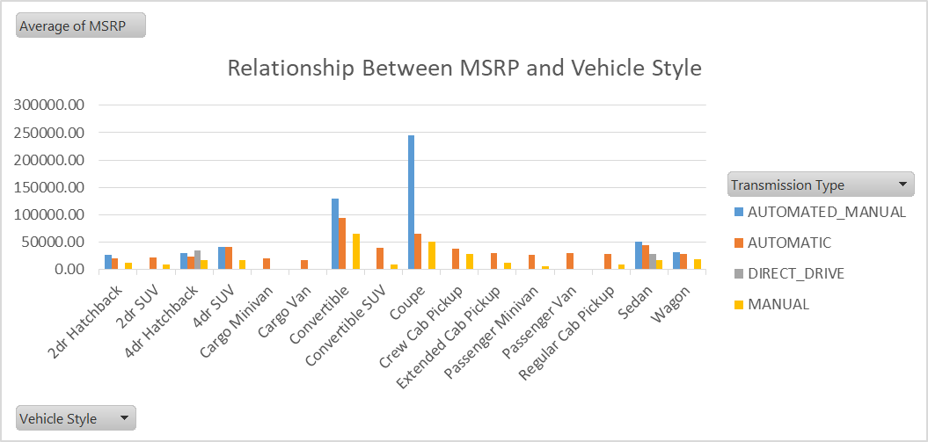

**Task 4:** How does the fuel efficiency of cars vary across different body styles and model years?

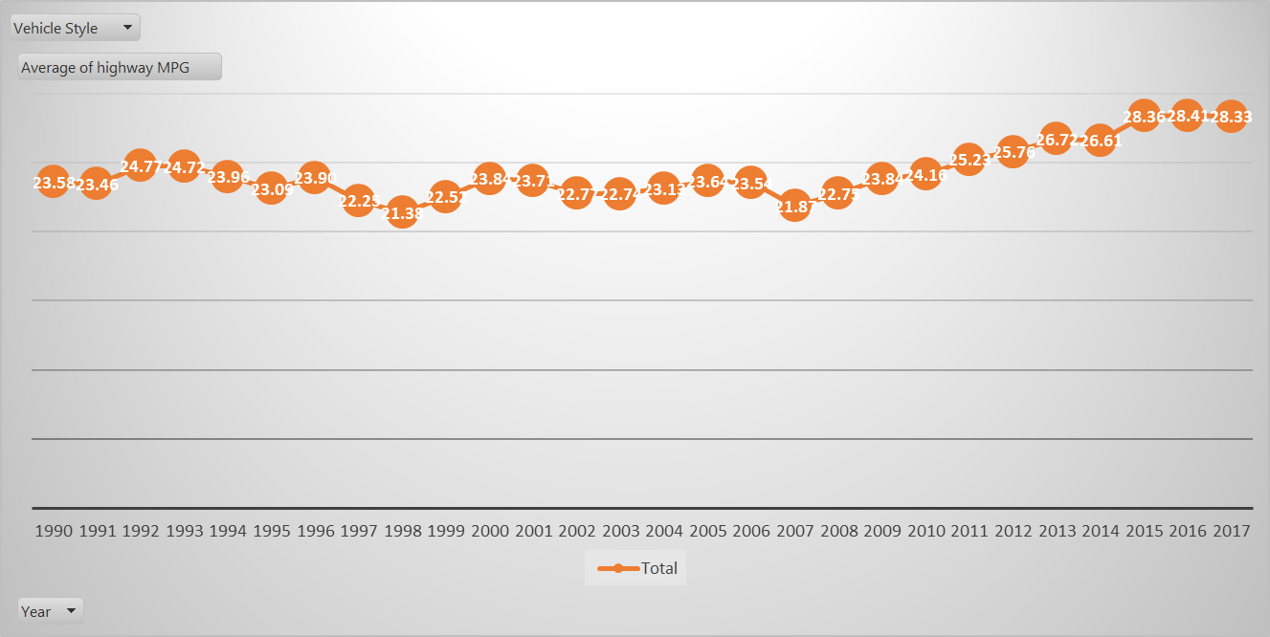

**Task 5:** How does the car's horsepower, MPG, and price vary across different Brands?

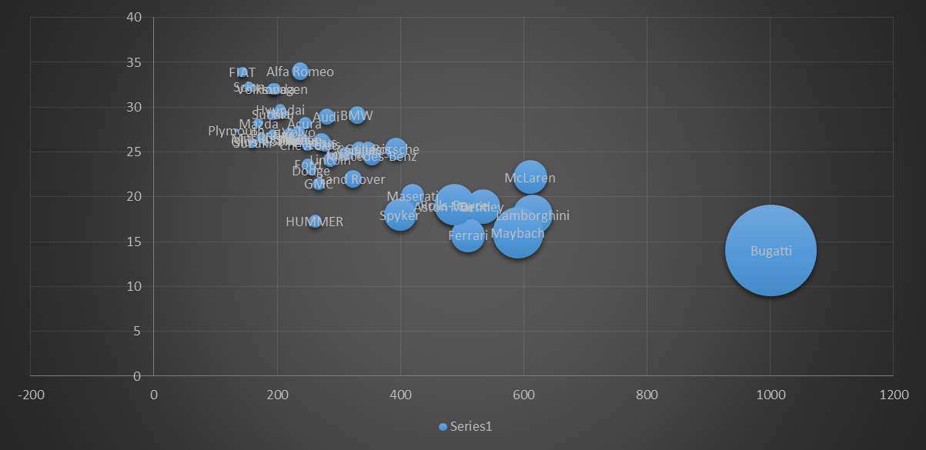

**FINAL DASHBOARD**

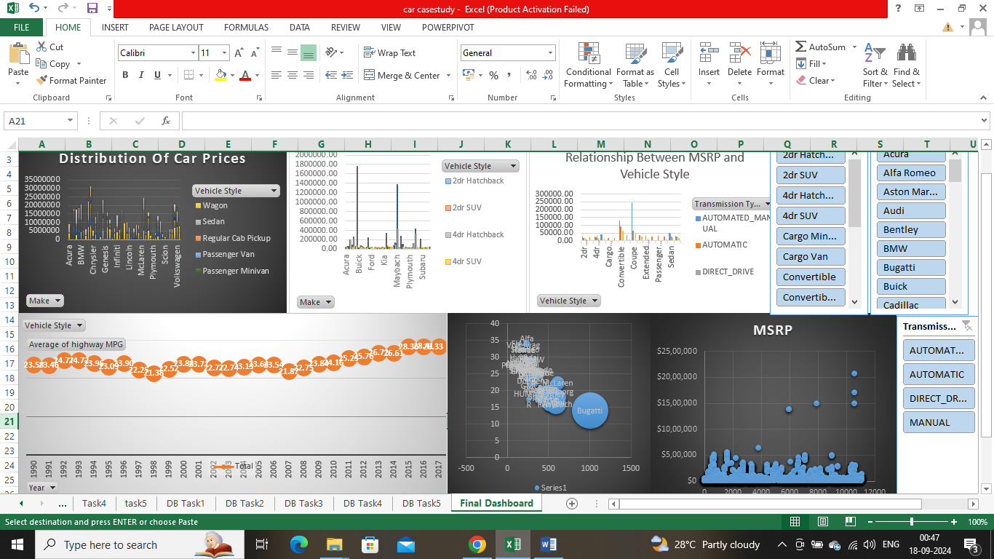

[**CARCASESTUDY**](https://docs.google.com/spreadsheets/d/1oRfF049ge_sLt4kHIY8CGuCqdEbbS6sh/edit?usp=sharing&ouid=111852951956959348349&rtpof=true&sd=true)